## Lesson 4 – Activity Sheet

## Getting Started

## Different outputs can be used in different situations. We might need to power a motor to move or enable an LED light to see better, or even sound an alarm when the vehicle is approaching to warn human workers.

* The LEDs can be on or off and are RGB programmable, so a range of colours can be used to signal different things
* The motors can be adjusted for power as well as how long they are going to be on for. We can also change the direction of each wheel to turn the vehicle
* The buzzer is a simple on or off

## Success Criteria

* Flash the LEDs and control the colour being displayed
* Identify the motor changes needed for specific angles
* Enable and disable the buzzer

## Pro-tip

**Motors**

* Spin enables you to turn one wheel in one direction and the second in the other for tighter turns

**LEDs**

* You can use shift to move to the next LED but rotate will keep going round and back to the start

## Test Time

**Motor**

* What speed and time will enable the vehicle to turn
  1. 90 degrees
  2. 180 degrees
  3. 360 degrees
* What impact does the surface material have for turning times and speeds?

**LEDs**

* Make a single LED flash
* What is the shortest time the LED can support before it no longer flashes?
* Compare the use of shift and rotate

**Buzzer**

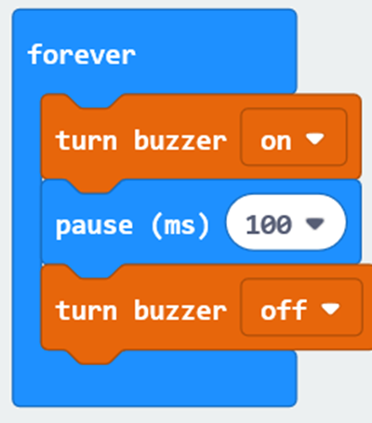

* Enable the buzzer for 3 seconds
* Pulse the buzzer 3 seconds on 3 seconds off

## Stretch Tasks

* Drive the robot in a triangle or other polygon pattern

## Start on the first LED and move it round one place to the end of the row and repeat the pattern

* Calculate the power and movement times for 10 degree turns based on your previous experiments

## Final Thoughts

* In this lesson we looked at different outputs
* We demonstrated how to apply different settings to the output to adjust the way the output is produced
* We have thought about how we can move the vehicle and the way in which we will need to calculate angles to make precise turns